Graph prototype examples

# Ancestor fan

Ancestor fan for Hebe, generated by Legacy 9

Quarter ancestor fan, generated by Legacy 9

# Booklet graph

Descendants of Chaos – factual – using Legacy 9

Descendants of Chaos – narrative – using Legacy 9

# Force-directed graph layouts

D3JS

<https://d3-wiki.readthedocs.io/zh_CN/master/Force-Layout/>

Force-directed tree layouts: <https://bl.ocks.org/mbostock/1062288>

# Radial tree

Radial cluster dendrogram

<https://bl.ocks.org/mbostock/4339607>

# Balloon tree

# Treemap layout

<https://d3-wiki.readthedocs.io/zh_CN/master/Treemap-Layout/>

# General hierarchical graphs

D3JS+D3JS and Graphlib

Prototype 1

Prototype 2 & 3

Top half inclusive bordering

Bottom half angling

# General family tree structures

Repeating duplicate names

Not really able to highlight incestuous relationships.

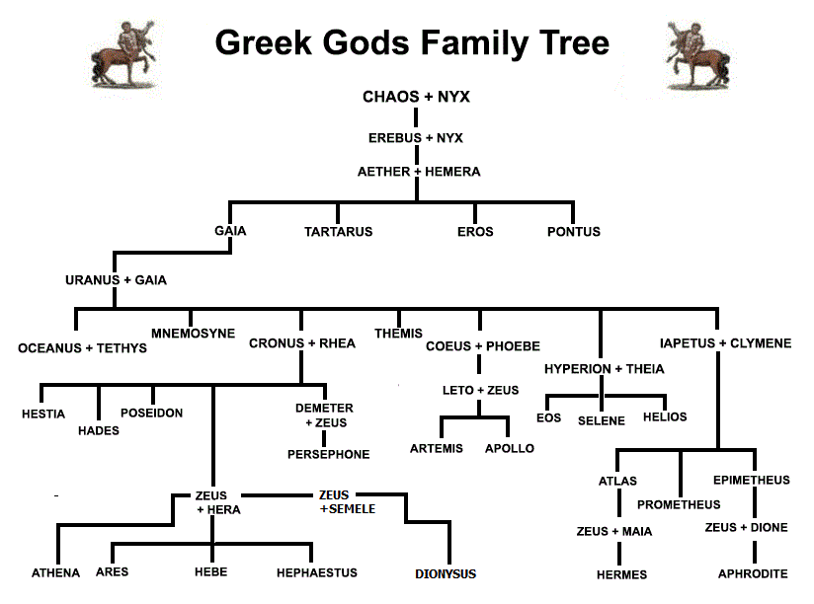

Ancestor and descendant diagrams (separate) for entities – Legacy 9

Vertical genealogical graph

Horizontal genealogical graph

# Incompatible graph layout types

1. TimeNets
2. Timeline graph

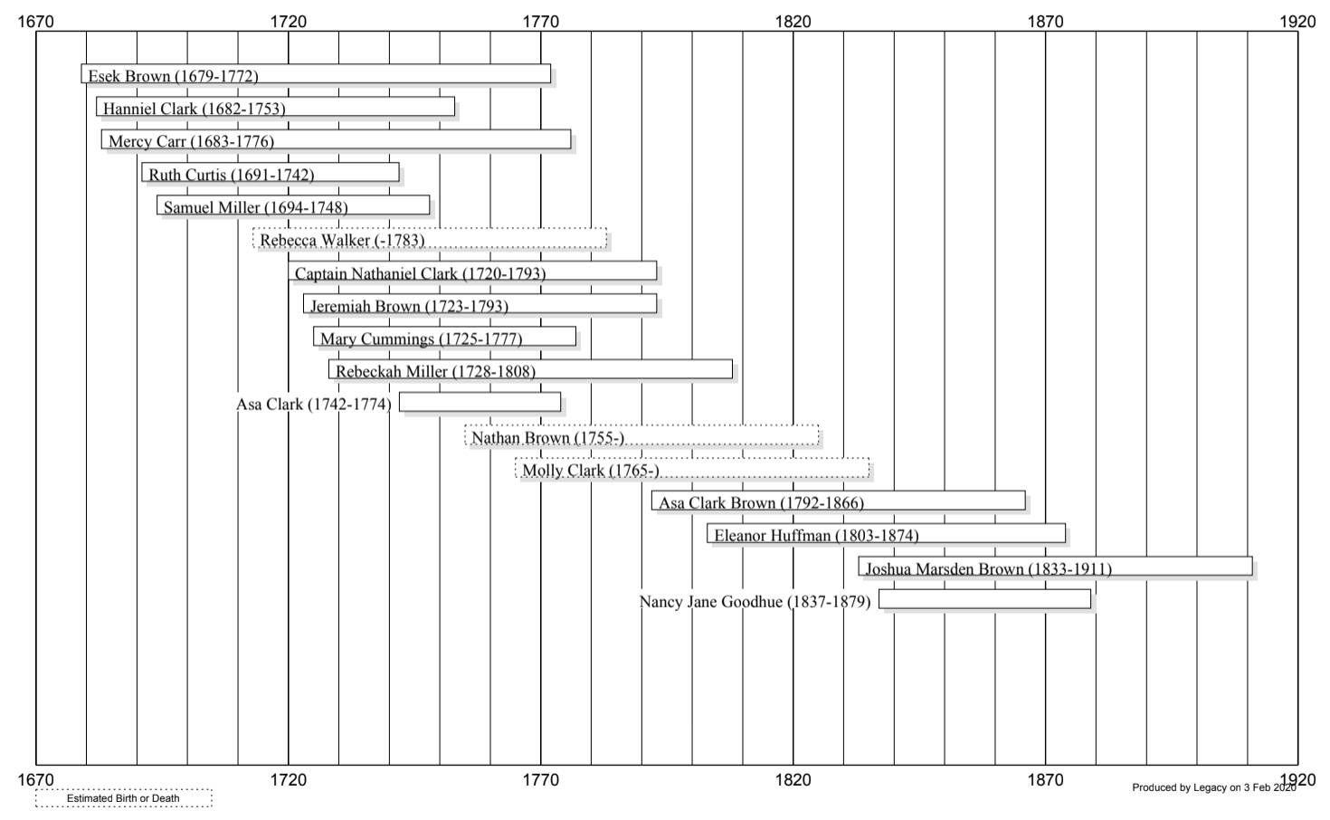

1. Chordal diagrams

Based on Hott research paper as a respresentation of polygamy. Difficult to understand.

